**Handsman Threads – Elevating the Art of Sophistication in Men’s Fashion**

**Prepared by:Punugupati Srilatha**

**Project Overview**

Handsman Threads is a premium men’s fashion brand that merges timeless tailoring with modern design.Its custom Salesforce CRM centralizes customer profiles, style preferences, and purchase histories for personalized service.Key features include automated order management, real-time inventory tracking, and integrated email notifications.The system streamlines customer engagement and operations, enabling data-driven decisions and scalable growth.

**Objectives**

The main goal of building the Salesforce CRM for **Handsman Threads** is to provide a seamless, personalized shopping experience that reflects the brand’s commitment to sophisticated men’s fashion. The system centralizes customer data—such as style preferences and purchase history—to enable tailored recommendations and targeted marketing. Automated order processing, real-time inventory management, and integrated communication tools streamline operations, reducing manual effort and errors. By improving customer management, enhancing operational efficiency, and delivering actionable insights, the CRM adds significant business value through increased customer satisfaction, stronger loyalty, and scalable growth.

**Phase 1: Problem Understanding & Industry Analysis**

**Requirement Gathering**

The primary need was a unified system to manage customer profiles, style preferences, purchase histories, and inventory for Handsman Threads’ premium men’s fashion line. Requirements focused on personalized service, automated order tracking, and analytics for sales trends.

**Stakeholder Analysis**

Key stakeholders included store managers, fashion consultants, sales staff, and customers.

Management required real-time insights, sales teams needed streamlined order handling, and

customers expected a tailored, seamless shopping experience.

**Business Process Mapping**

Existing processes—from customer onboarding and style consultation to order fulfillment and after-sales service—were mapped to identify inefficiencies such as manual inventory updates and fragmented communication. These were aligned to Salesforce objects and automation flows for smoother operations.

**Industry-Specific Use Case Analysis**

The men’s luxury fashion industry demands high personalization, fast response to style trends, and precise inventory control. Use cases included personalized styling recommendations, loyalty program management, and dynamic dashboards for tracking fashion-season sales.

**AppExchange Exploration**

Relevant Salesforce AppExchange solutions—like marketing automation apps, advanced inventory management tools, and AI-driven recommendation engines—were evaluated to extend core CRM functionality and accelerate implementation without heavy custom coding.

**Phase 2: Org Setup & Configuration**

**Salesforce Edition:** Enterprise Edition selected for advanced automation, multiple custom objects, and robust security.

**Company Profile Setup:** Configured Handsman Threads’ company details, default currency, and business address.

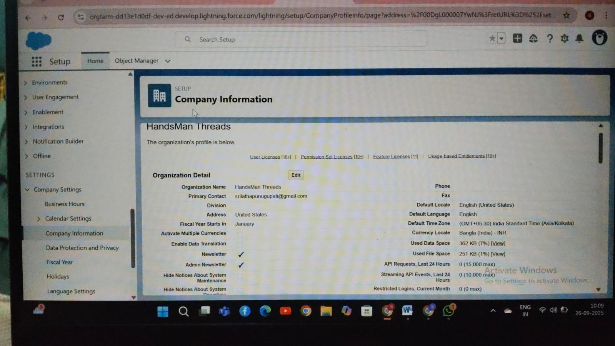

**Business Hours & Holidays:** Defined working hours and holidays for accurate workflow timing and automated follow-ups.

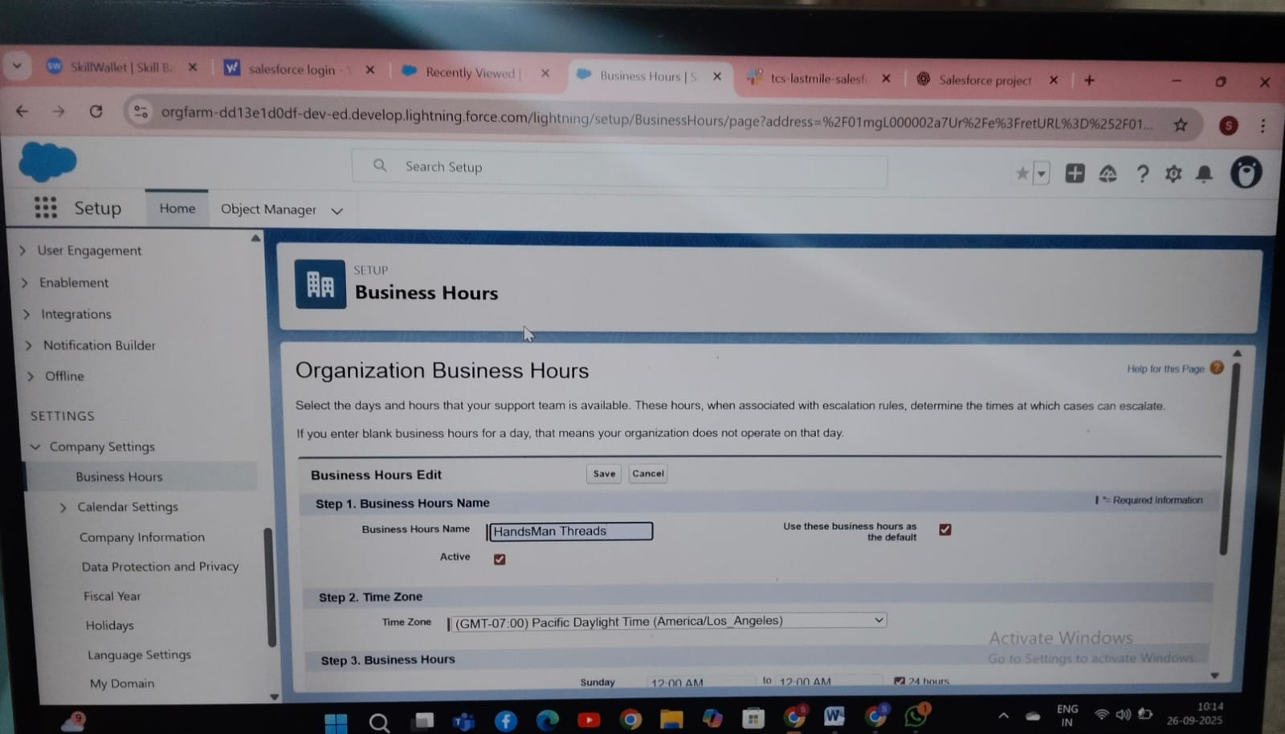

**UserSetup:** Added roles—Sales,Inventory,Marketing with corresponding licenses.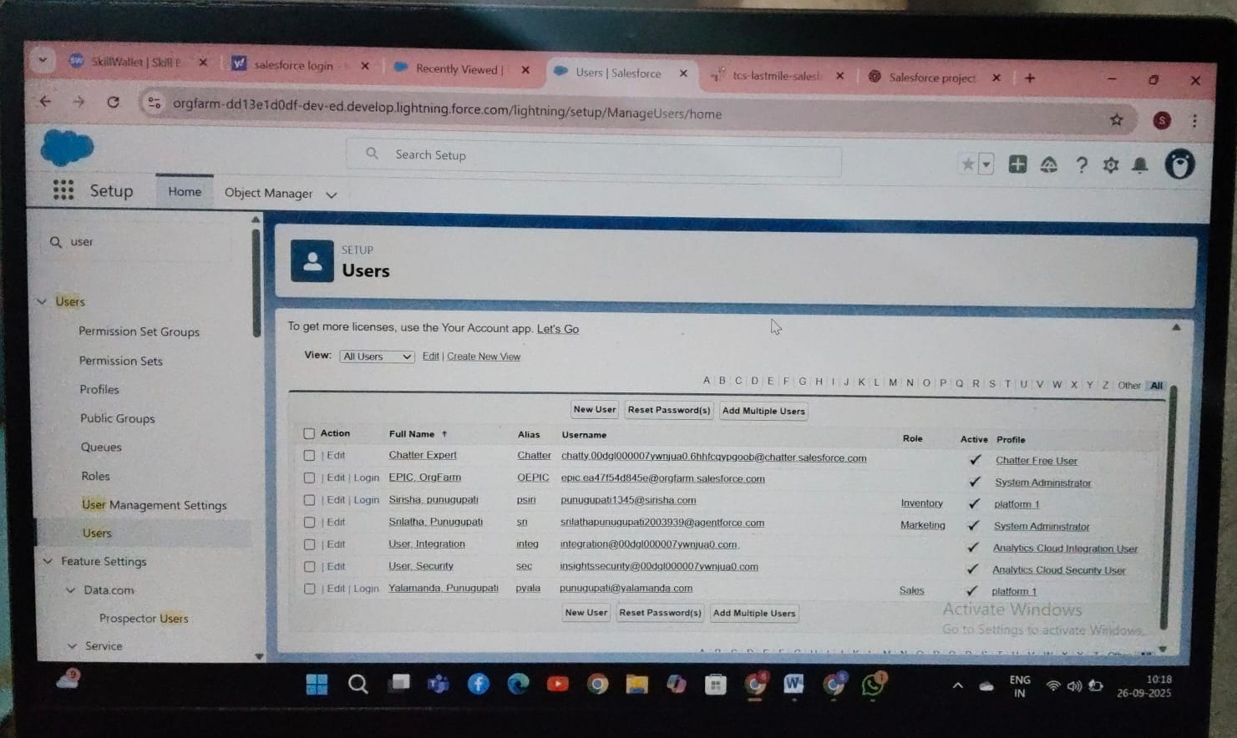

## ****Phase 3: Data Modeling & Relationships****

**Standard & Custom Objects:**

* Standard: Accounts, Contacts, Orders
* Custom: HandsMen Customer, HandsMen Product, HandsMen Order, Inventory, Marketing Campaign

**Fields:** Email, Phone, Loyalty Status, Order Date, Order Total, Stock Quantity, Preferred Fabric, Order Status, Inventory Threshold

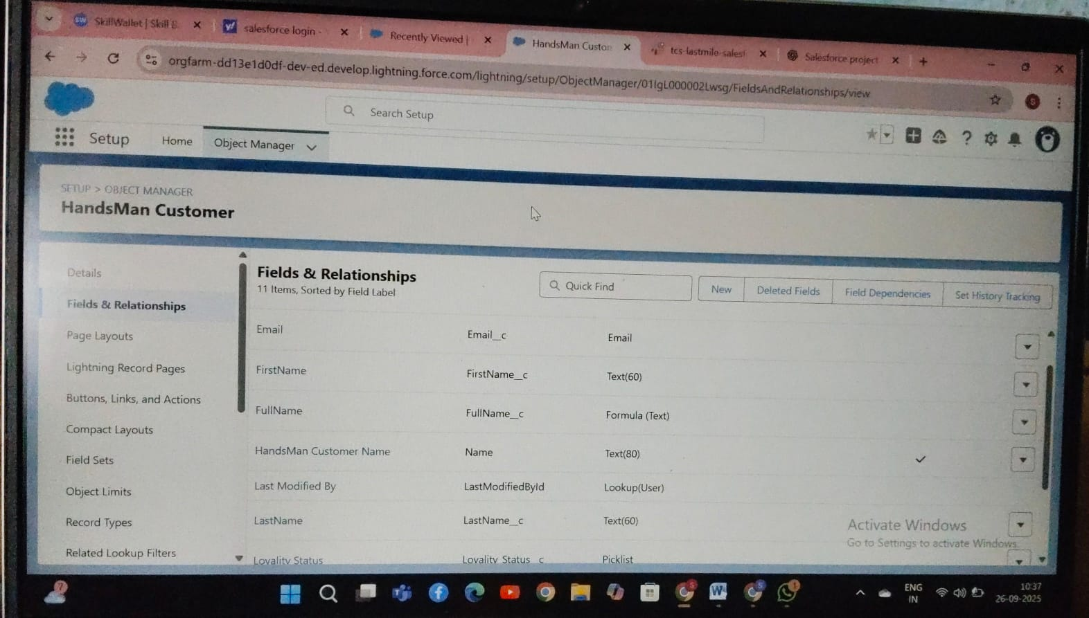

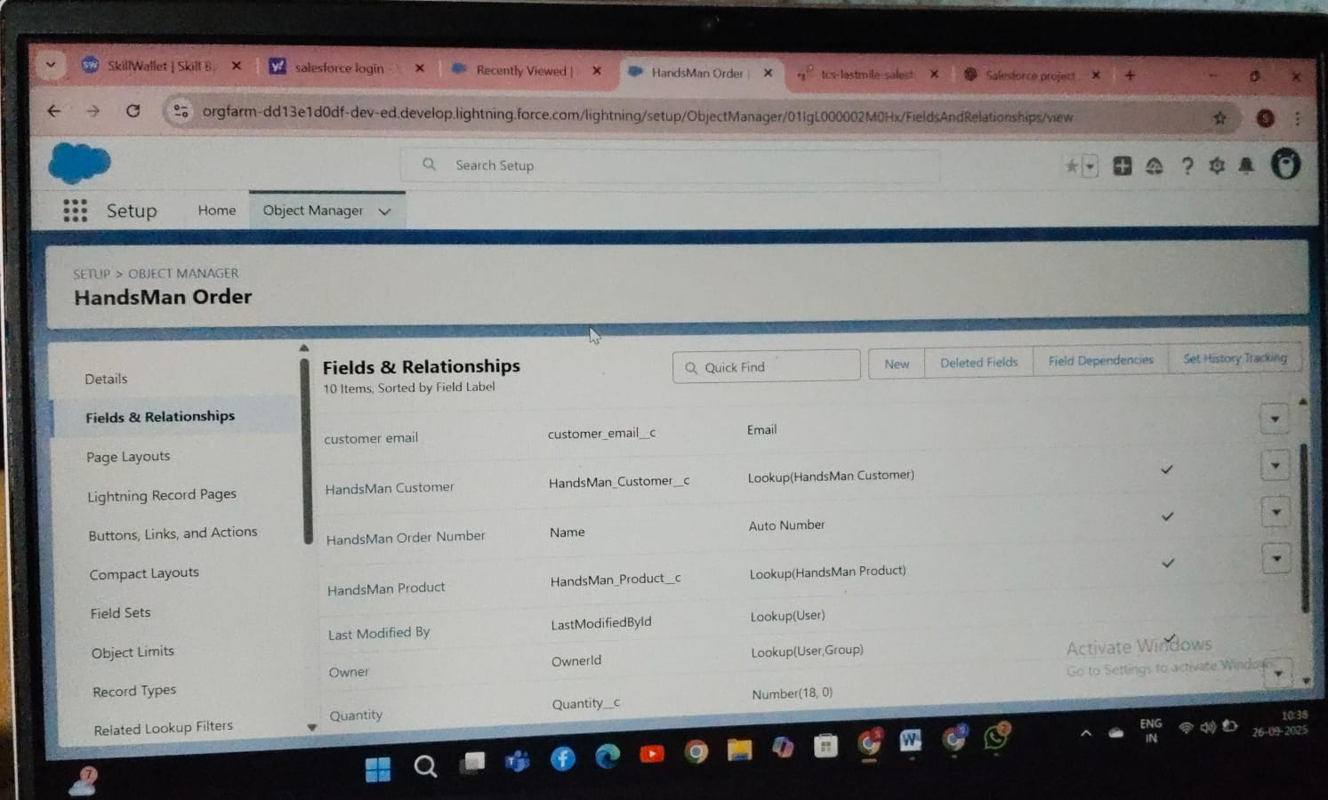

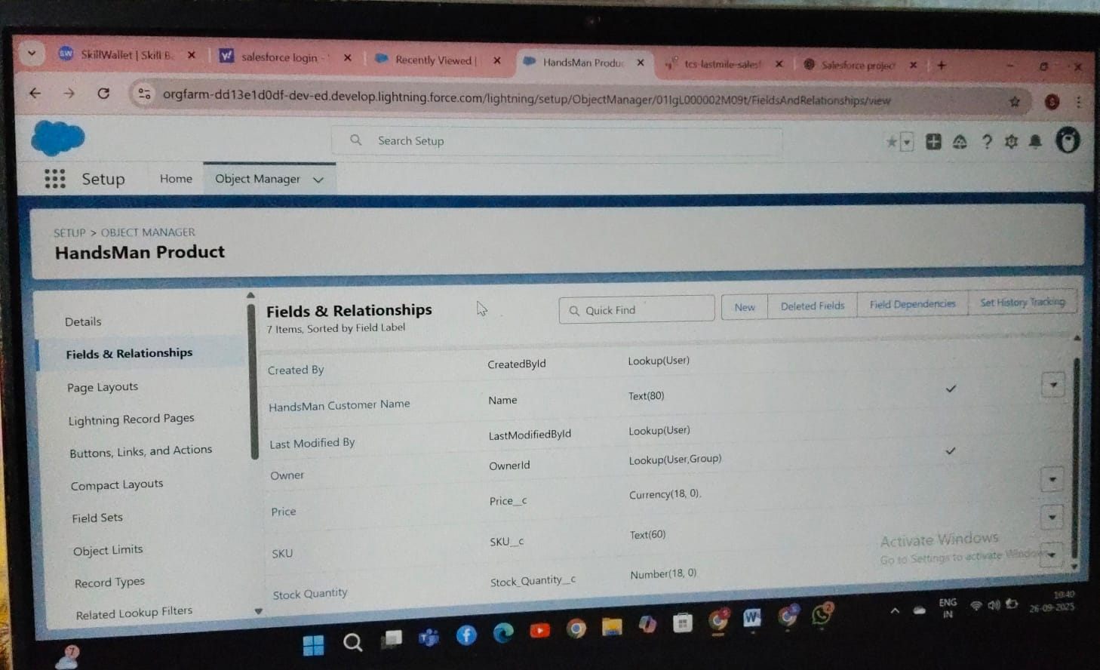

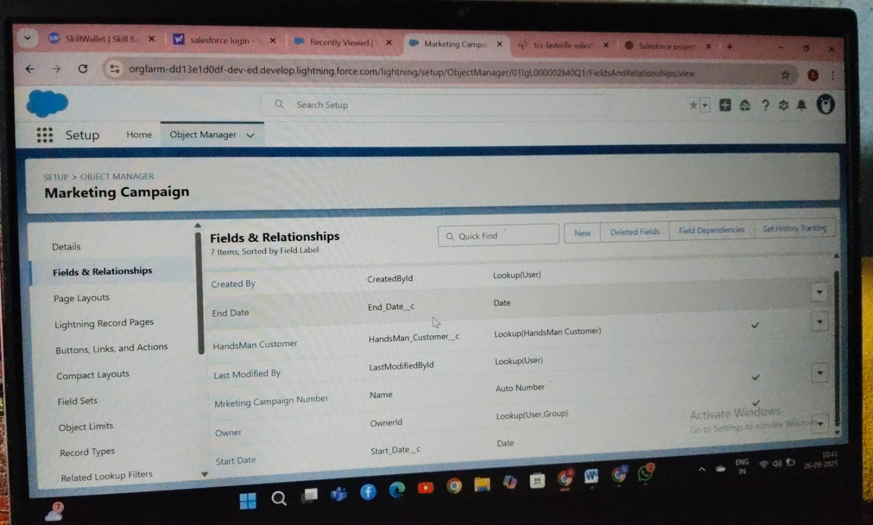

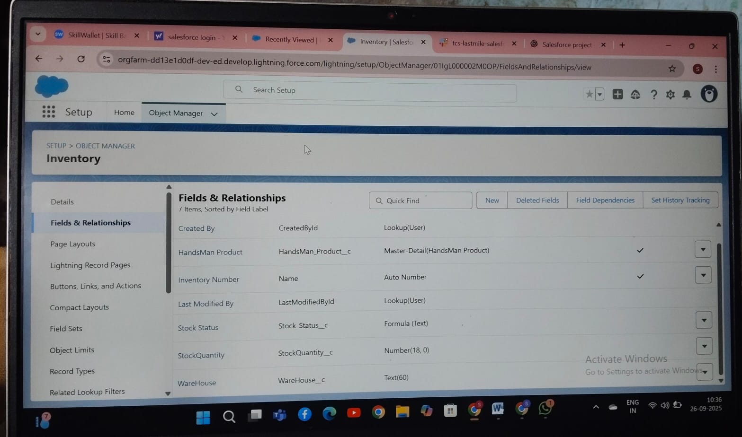

**Page Layouts & Compact Layouts:** Custom layouts for roles to display relevant fields; compact layouts for quick mobile access.

## ****Phase 4: Process Automation (Admin)****

**Validation Rules:**

* Prevent invalid email, negative inventory, or incomplete order details

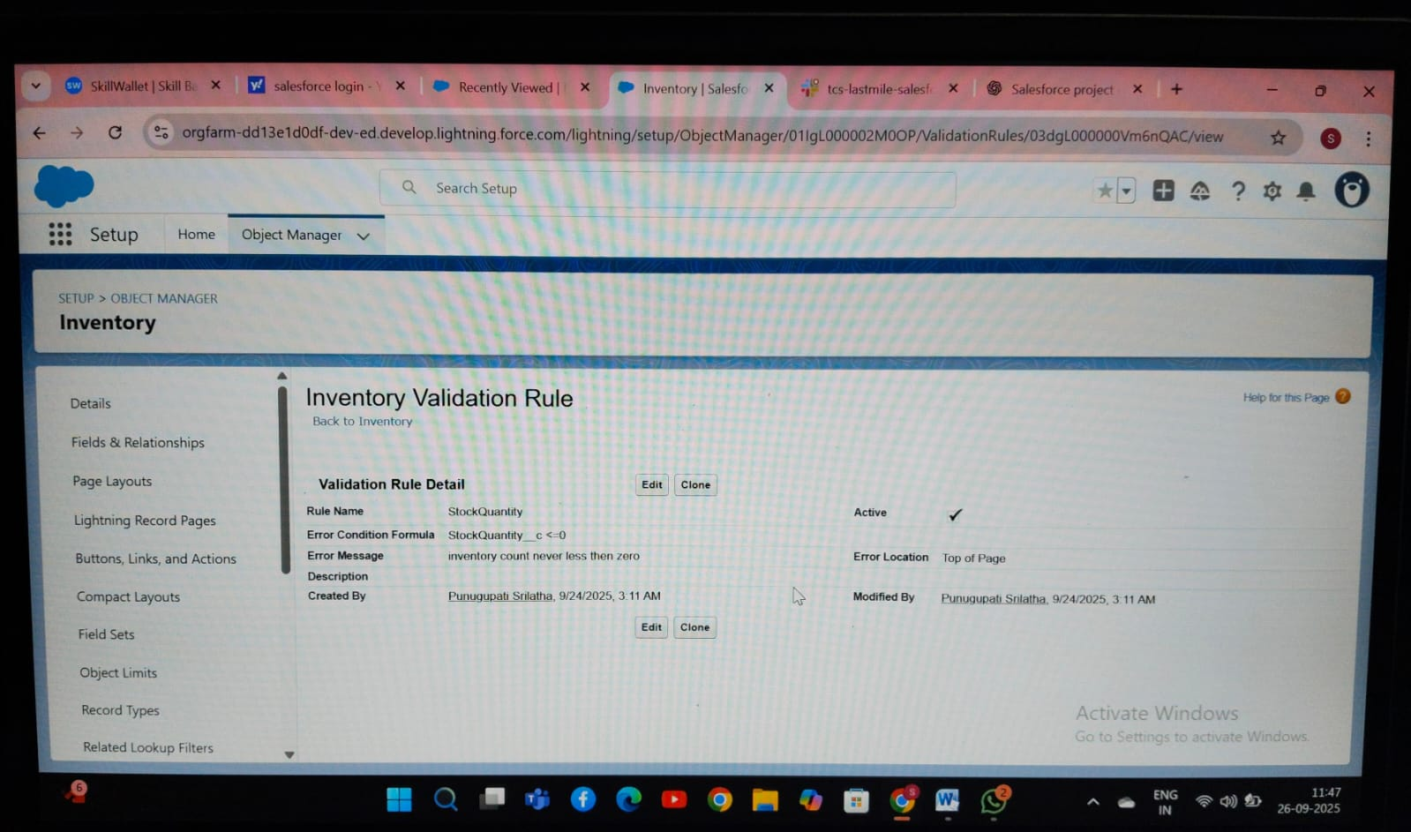

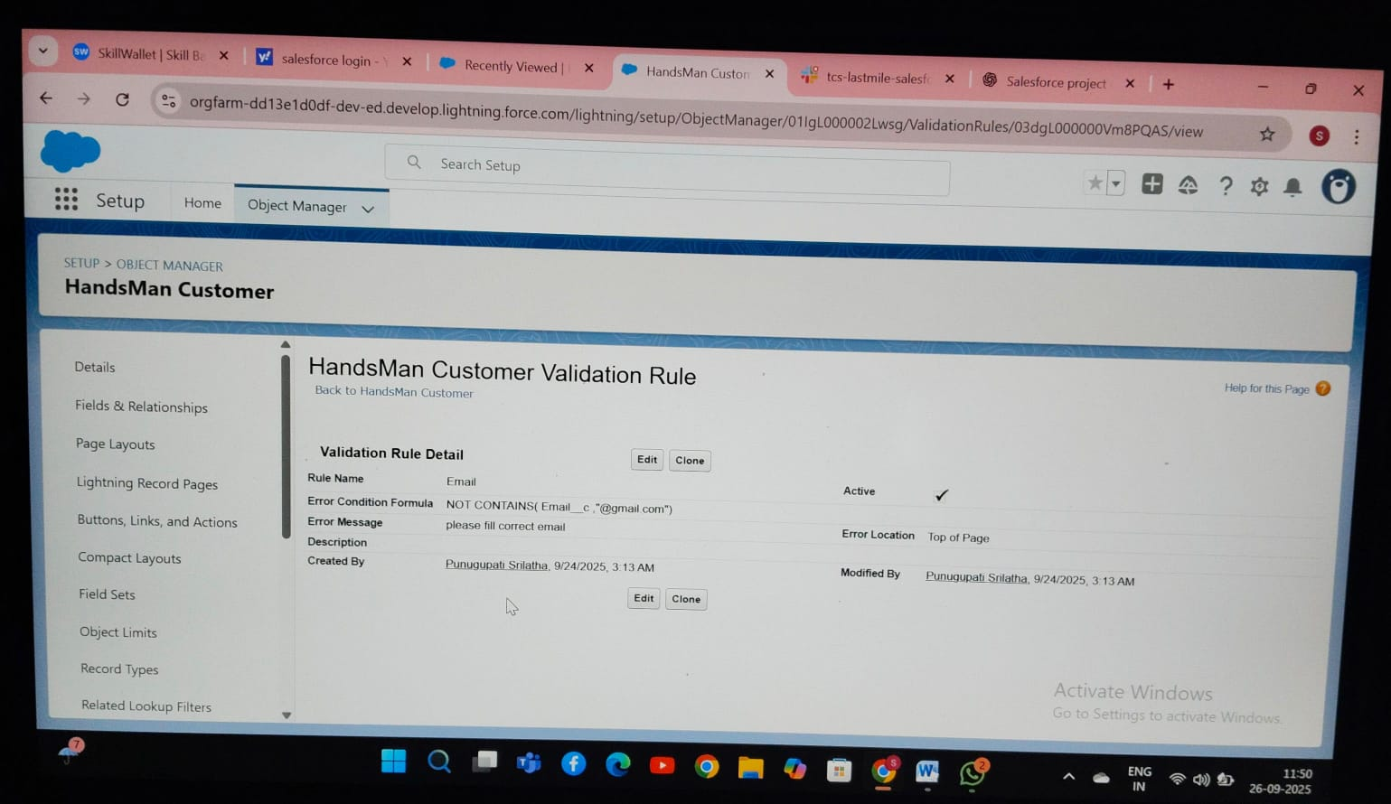

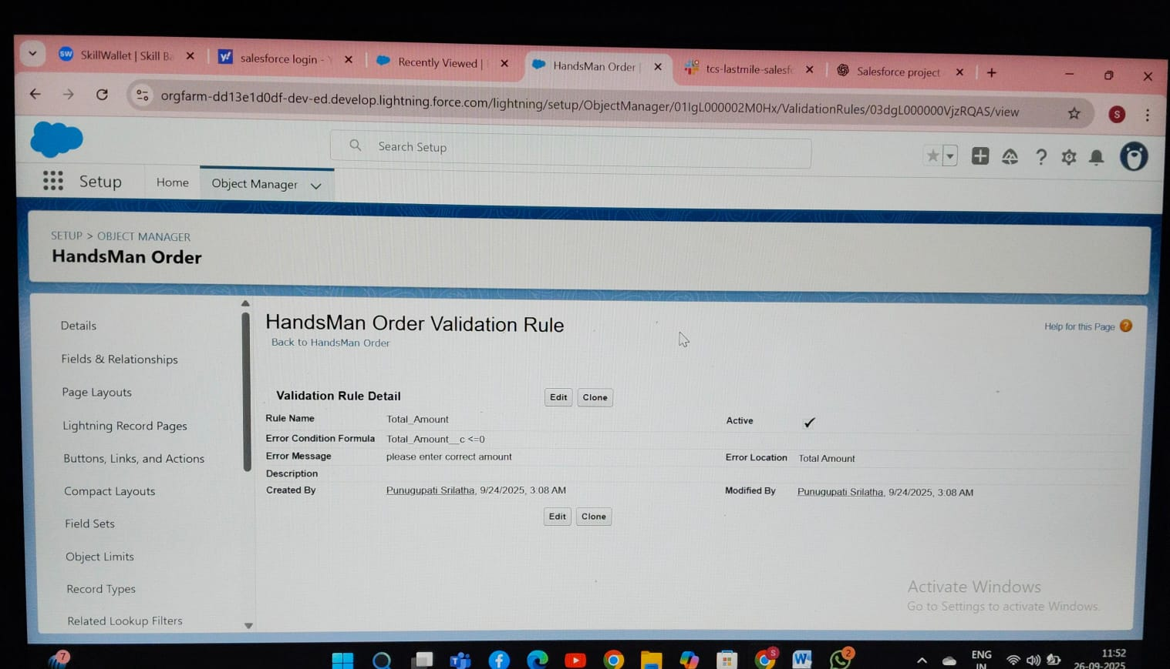

**Workflow Rules & Approval Processes:**

* Automated task assignment for approvals of bespoke orders

**Flow Builder:**

* Record-Triggered Flows: Order Confirmation, Stock Alert
* Scheduled Flow: Loyalty Status Update (daily)

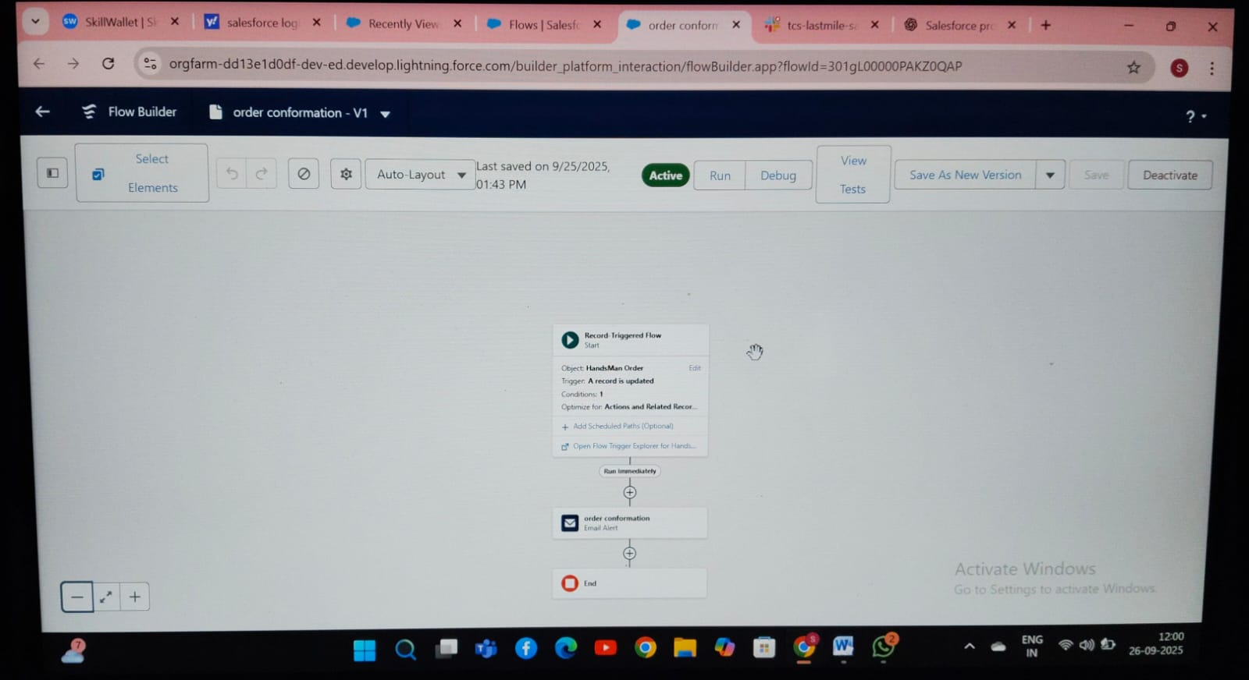

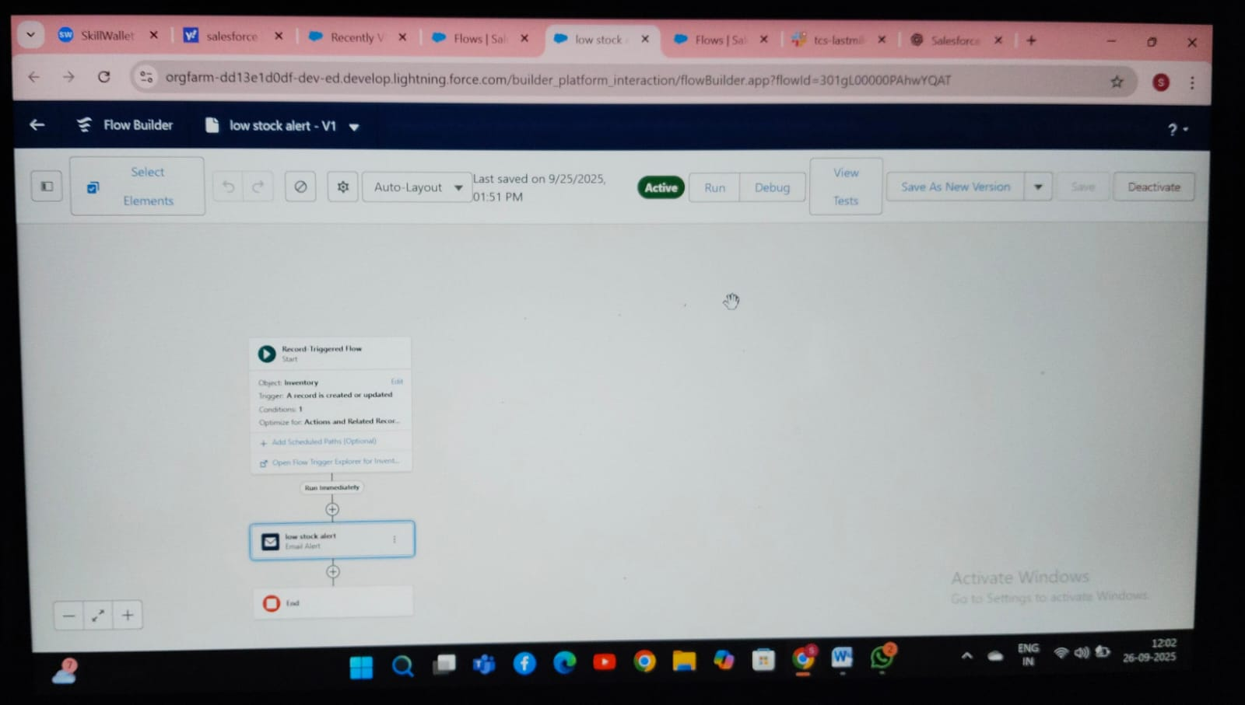

**Email Alerts & Templates:**

* Order Confirmation, Shipping Notification, Loyalty Points Update

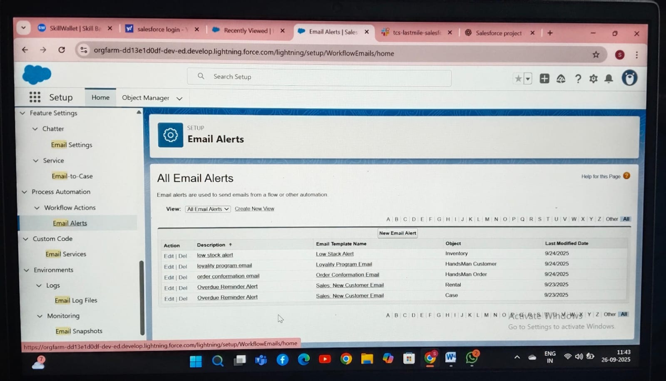

**Field Updates & Custom Notifications:**

* Automatic updates of order totals, loyalty points, and inventory alerts

## ****Phase 5: Apex Programming (Developer)****

**Classes & Triggers:**

* Apex Triggers on Orders (before insert/update) for validation and notifications
* Trigger Design Pattern used for scalable code management

**SOQL & SOSL:** Queries for retrieving customer orders, loyalty points, and inventory alerts

**Collections:** Lists, Sets, and Maps to manage order items and stock updates efficiently

**Asynchronous Processing:** Batch Apex and Scheduled Apex for loyalty updates and bulk order processing

**Exception Handling & Test Classes:** Ensured all triggers and classes have robust error handling and 100% test coverage

## ****Phase 5: Apex Programming (Developer)****

**Classes & Triggers:**

* Apex Triggers on Orders (before insert/update) for validation and notifications
* Trigger Design Pattern used for scalable code management

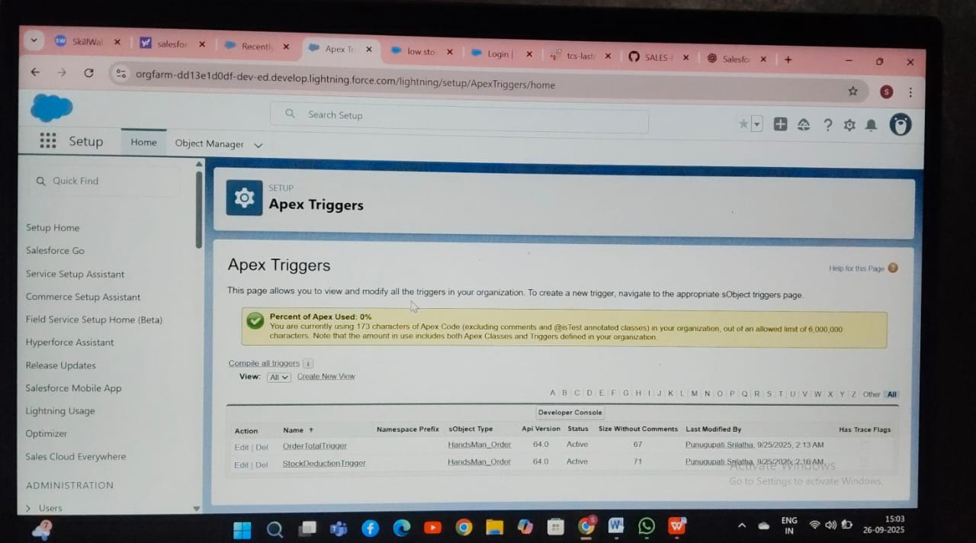

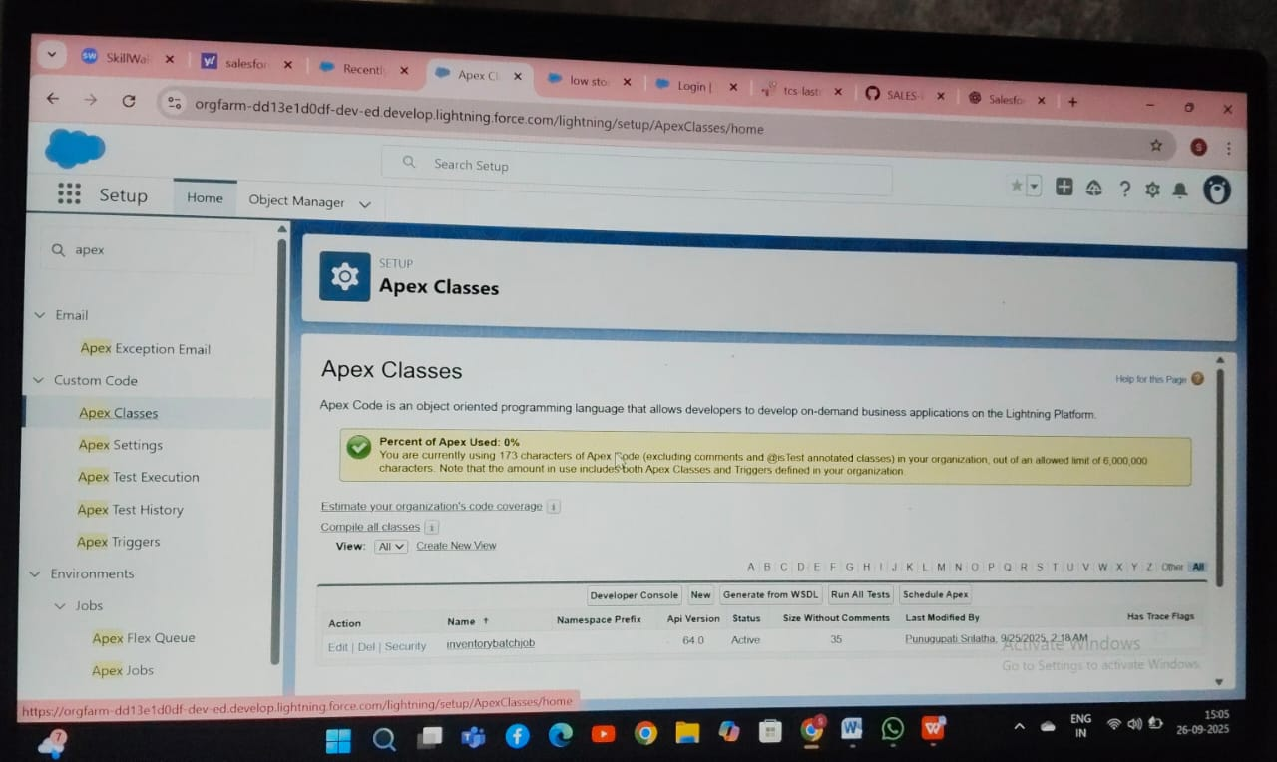

**SOQL & SOSL:** Queries for retrieving customer orders, loyalty points, and inventory alerts

**Collections:** Lists, Sets, and Maps to manage order items and stock updates efficiently

**Asynchronous Processing:** Batch Apex and Scheduled Apex for loyalty updates and bulk order processing

**Exception Handling & Test Classes:** Ensured all triggers and classes have robust error handling and 100% test coverage

## ****Phase 6: User Interface Development****

**Lightning App Builder & Record Pages:** Customized pages for Orders, Customers, Products, Inventory

**Tabs:** HandsMen Customer, HandsMen Product, HandsMen Order, Inventory, Marketing Campaign

**Home Page & Utility Bar:** Quick links to flows, reports, and dashboards for Sales Executives

**LWC & Apex Integration:**

* Display loyalty points dynamically using Apex calls
* Event handling for real-time stock alerts

**Wire Adapters & Navigation Service:** Ensured smooth user interactions and record navigation

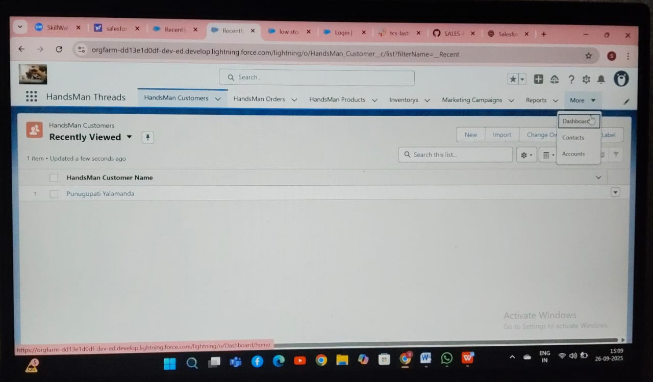

**Phase 7: Integration & External Access**

**Named Credentials & External Services:** Integrated supplier catalog via Salesforce Connect

**Web Services (REST/SOAP) & Callouts:** Fetch external inventory data for real-time stock management

**Platform Events & Change Data Capture:** Notify inventory managers of low stock and order changes

**API Limits & OAuth:** Managed secure access and API quotas

**Remote Site Settings:** Configured for all external integrations

**Phase 8: Data Management & Deployment**

**Data Import Wizard & Data Loader:** Used for initial customer and product uploads

**Duplicate Rules:** Prevent repeated customer or product entries

**Data Export & Backup:** Scheduled backups for disaster recovery

**Change Sets & VS Code / SFDX:** Deploy metadata and flows to production

**Phase 9: Reporting, Dashboards & Security Review**

**Reports:** Tabular, Summary, Matrix reports for sales, orders, inventory

**Dashboards:** Dynamic dashboards for sales KPIs, loyalty program stats, and stock levels

**Profiles, Roles & Permission Sets:** Controlled access per role

**OWD & Sharing Rules:** Ensured data visibility based on hierarchy

**Field Level Security & Session Settings:** Protect sensitive fields and limit login access

**Audit Trail:** Tracks changes for compliance and accountability

**Phase 10: Quality Assurance Testing**

**Test Cases Prepared For:**

* Record creation for Customers, Orders, Products
* Approval processes for bespoke orders
* Flows for order confirmation, stock alerts, loyalty updates
* Validation rules for emails, stock levels, and required fields

